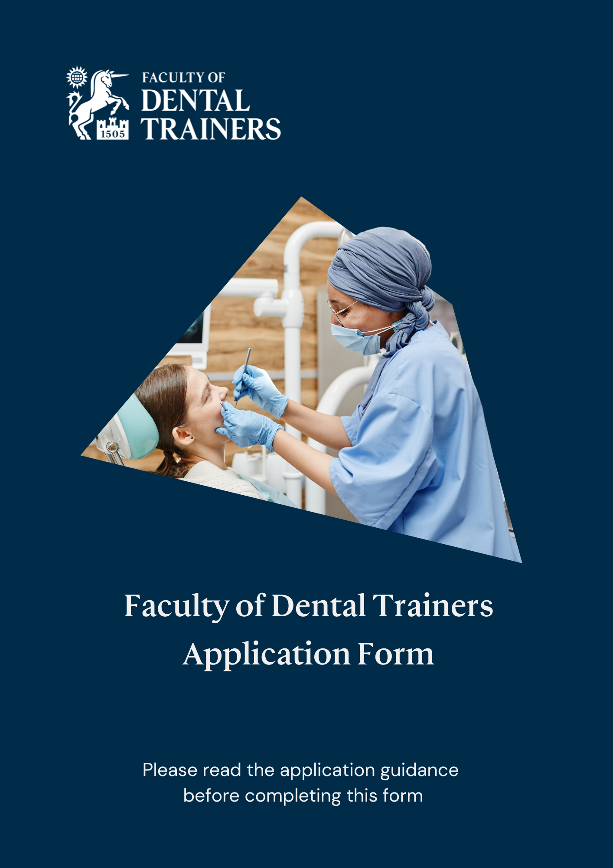
Faculty of Dental Trainers

Please refer to the guidance documentation and submit all your details on this form, which should be completed electronically, and in NO SMALLER THAN SIZE 9-POINT FONT. ONLY EVIDENCE THAT IS SPECIFIC TO DENTAL EDUCATION AND TRAINING SHOULD BE INCLUDED and this should be listed and/or presented as a succinct summary. NO MORE THAN SIX A4 PAGES MAY BE USED TO PRESENT YOUR EVIDENCE FOR THE THREE DOMAINS. Evidence should be placed using the headings within the boxes for each domain. Evidence should not be duplicated between the headings and domains. PLEASE NOTE THAT NOT ALL DOMAINS OR THE HEADINGS WITHIN THEM REQUIRE TO BE COMPLETED. Where you do not have evidence, leave a blank space.
You are advised to look at the guidance on the website at https://fdt.rcsed.ac.uk/how-to-join/ and refer to the table Examples of Evidence at https://fdt.rcsed.ac.uk/how-to-join/educational-domains-and-examples-of-evidence/ which lists examples of activities relevant for inclusion on this application. If reapplying , please refer to your original application and highlight the additional evidence you have acquired.

Please retain all supportive documentation in respect of this application. The College reserves the right to request submission of this or additional evidence should further clarification be required to assist in the adjudication process.
Do not send in supplementary information

Level applying for:
ASSOCIATE: ☐  Submission requirements:  - Application form  - Letter of support  N.B. Applicants for Associate should not complete the boxes for domains 1, 2 & 3. | MEMBER ☐  Submission requirements:  - Application form | FELLOW ☐  Submission requirements:  - Application form  - Two structured references supportive of the development and impact of the contribution to education/training made by the applicant and two completed and signed referee forms  .

- Personal Details

First Names
Last Name
Title
Gender
Date of birth
Phone number
Email address
RCSEd College Reference Number  *This is a five to six digit reference number that can be found by logging in to your RCSEd online account |  | 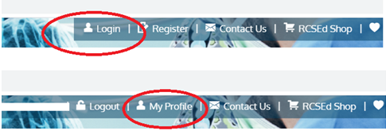  www.rcsed.ac.uk
Postal address
Are you a RCSEd Affiliate, Member or Fellow? If yes, please give details of awards with dates.

- Current employment

Job title
Specialty
Employer
Place of employment
Date commenced

- Qualifications

Primary dental qualification
Year gained
Awarding institution
Country

- Probity declaration

I declare that I have not, in the UK or outside:
- Been convicted of a criminal offence (including any spent convictions) or have proceedings pending against me.
- Been subject to disciplinary proceedings, reprimand or suspension by the General Dental Council in the United Kingdom or any equivalent Regulatory or Licensing Body elsewhere.
- Been erased from the Register of the relevant registering body or failed to comply with conditions or qualifications imposed by the relevant registering body under performance review procedures.
- Had any disciplinary actions taken against me by an employer or contractor or have had any contract terminated or suspended on grounds relating to my fitness to practice.

I confirm that I am:
- in active clinical or teaching practice ☐
- in good professional standing ☐

By signing below, you confirm that all the information provided on the application form is correct.

Signature:

Date:

PLEASE RETURN COMPLETED FORM BY EMAIL TO: fdt@rcsed.ac.uk

Faculty of Dental Trainers
Royal College of Surgeons of Edinburgh
Nicolson Street
EDINBURGH
EH8 9DW

By submitting this application, you understand that RCSEd will process your personal data in accordance with the terms of the General Data Protection Regulation (GDPR).

We will not share your data with any third party unless there is a statutory requirement for us to do so or unless we require to do so to deliver our services. Such sharing will only be undertaken where the appropriate Data Processing Agreements are in place and for tightly controlled purposes. The College will retain your data for the periods of time described in our privacy statement. Further details may be found on our website at https://www.rcsed.ac.uk/privacy.
Evidence in support of application

DOMAIN 1: TEACHING AND TRAINING ACTIVITIES
(Please summarise your teaching and training experience by using the bullet point headings below) Please include all postgraduate activities.
- Clinical supervision

- Training undertaken to become a trainer, e.g. Training the Trainers course or equivalent

- Examinerships

- Awards in teaching and training

- Delivery of education/training courses

- Description of involvement in workplace-based assessments and feedback

DOMAIN 2: EDUCATIONAL LEADERSHIP ACIVITIES
(Please summarise and justify your educational leadership experience using the bullet point headings below)
- Educational Supervisor

- Educational course leader/co-ordinator

- Training Programme Director

- Curriculum development

- Senior role in dental education

- Contribution to relevant education boards

DOMAIN 3: PUBLICATION, RESEARCH, SCHOLARSHIP ACTIVITIES
Please only include qualifications, publications and presentations DIRECTLY RELATED TO the subjects of dental education/training. RESEARCH ARTICLES THAT ARE NOT ON THE SUBJECTS OF DENTAL EDUCATION, TEACHING AND TRAINING MUST NOT BE SUBMITTED AS EVIDENCE. (Please summarise your experience using the bullet point headings below)
- Higher qualification in dental education- e.g. Certificate/Diploma/Fellow of Higher Education Academy

- Higher qualification in dental education - Master/PhD

- Development of educational material

- Publications on dental education/training in peer reviewed journals

- Presentations in dental education/training

- Supervision of research in dental education/training for paper/higher degree

- Contributions to dental educational/training policy documents

